ST. XAVIER’S COLLEGE

**Maitighar,Kathmandu**

**(Affiliated to Tribhuvan University)**



**Database Management System**

**Lab Assignment #7**

**Submitted By**

Aashish Raj Shrestha

B.Sc. CSIT

Year II/IV Semester

013BSCIT002

**Submitted To**

Er. Sanjay Kumar Yadav

Lecturer,

Department of Computer Science

St. Xavier’s College

Maitighar, Kathmandu

**Submitted On**

September 27, 2015

1. SELECT

**Q. Find eno ,ename of the employee whose salary is greater than 4000.**

*SELECT eno, Ename, Salary FROM Employee WHERE salary >4000*

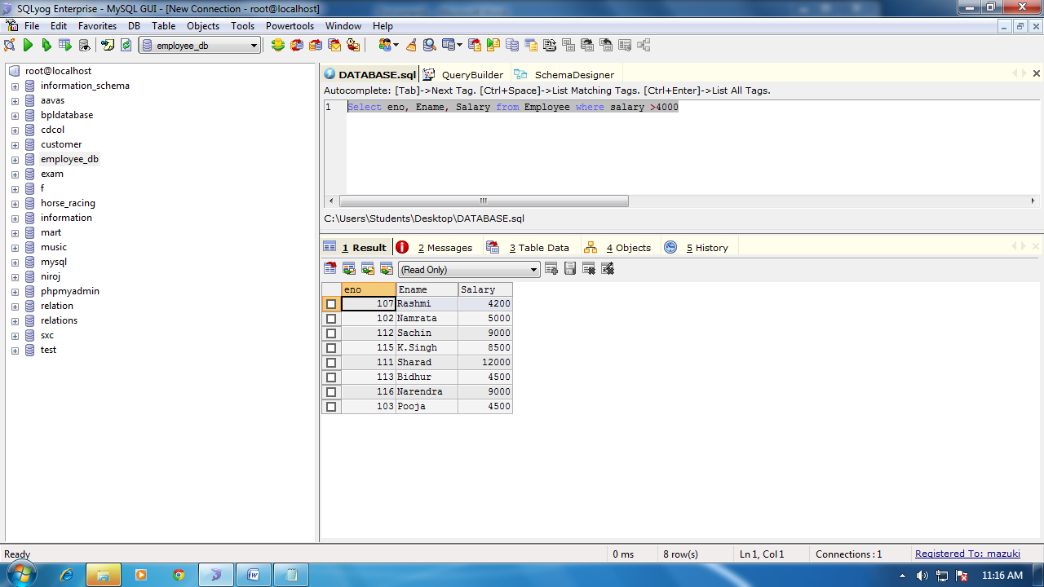

1. COMBINING CONDITION AND BOOLEAN EXPRESSION

**Q.Find eno ,ename, salary of the employees whose salary is greater than 5000 and job status is professor.**

*Select eno, Ename, Salary from Employee where salary >4000 and Job_status = "Professor"*

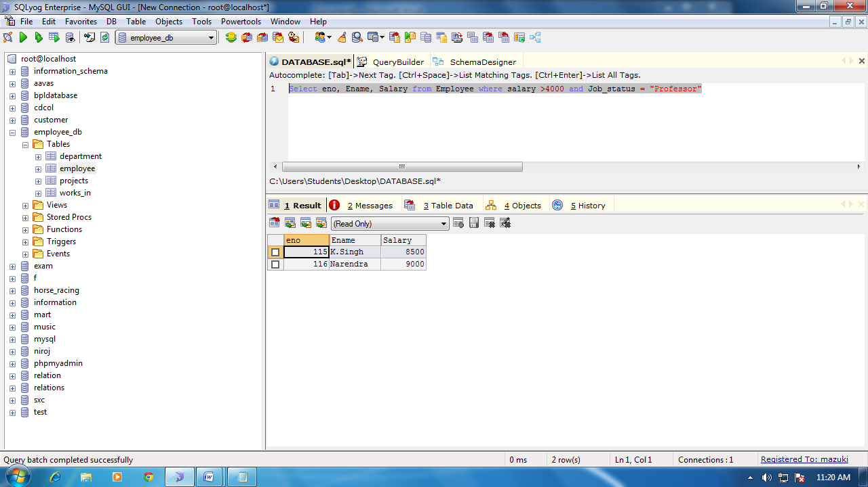

1. REMOBVING DUPLICATES

**Q. Find eno, ename, salary of the employee whose department number is 20 or job_status Research Fellow.**

*Select eno, Ename, Salary from Employee where DepNo=20 or Job_status = "Research Fellow"*

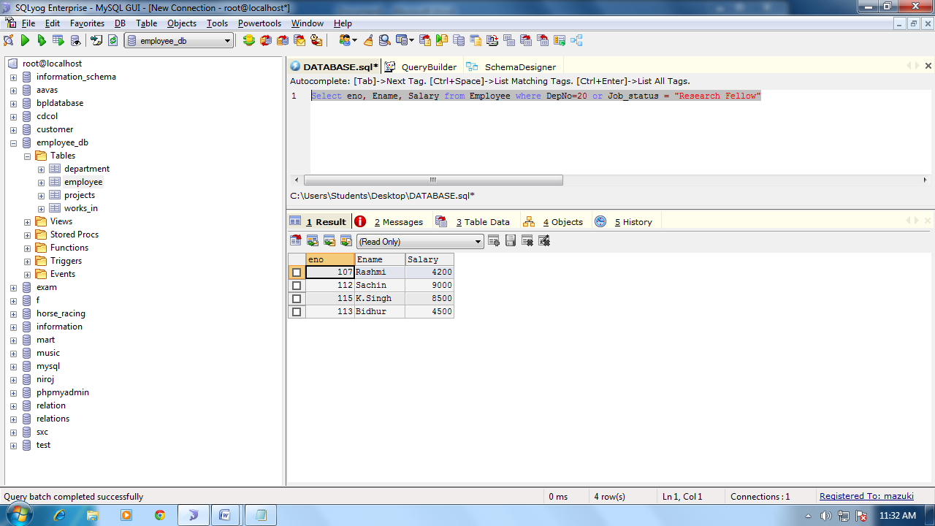

1. RANGE SPECIFICATION

**Q. Find the Eno, ename, age and salary from the employees where the age is between 24 and 28.**

*Select eno, Ename, age, Salary from Employee where age between 24 and 28*

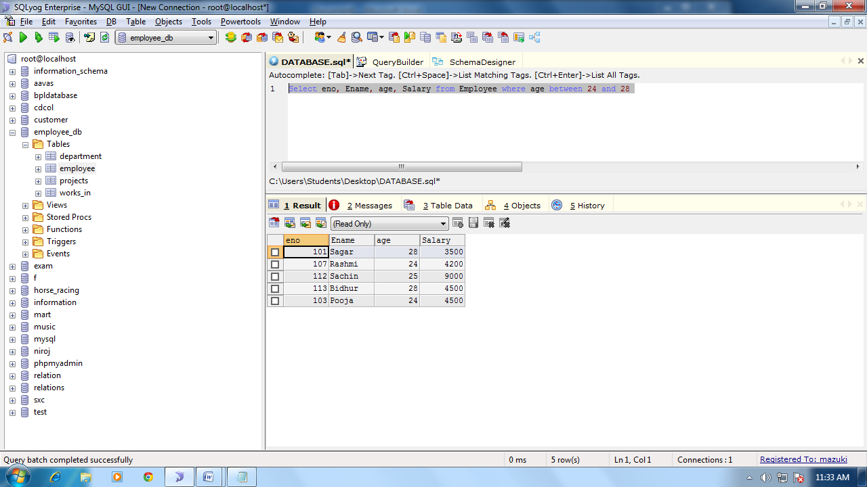

1. STRING OPERATIONS

**Q. Select eno, ename, whose starting letter SA.**

*Select eno, Ename from Employee where Ename like 'sa%'*

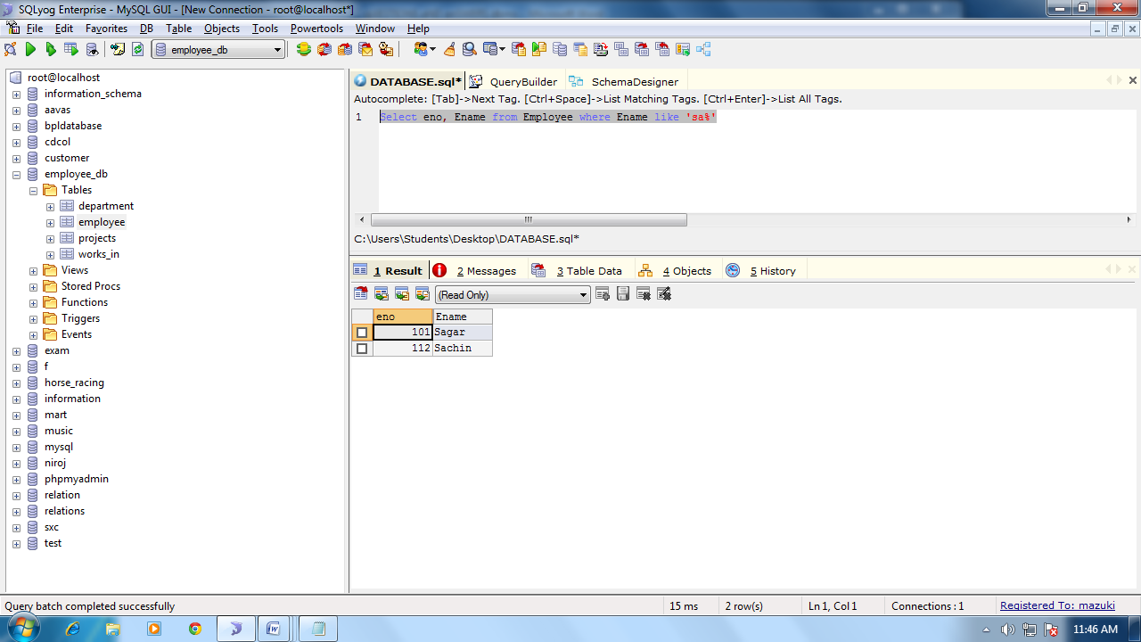

**Q. List all Employee names with their Project Name**

*Select Ename,Pname from Employee join projects where employee.DepNo=projects.DepNo*

**Q. List name of all employee and their salary who are working in project mars or venus**

*Select Ename,Salary from Employee join projects where employee.DepNo=projects.DepNo and Pno = 'M110'*

***Q. List name of all employee and their salary who are working in project Earth and Venus.***

**Q. List name and address of all employees who works in department which is located in Pokhara.**

*Select Ename, Address from Employee join department where employee.DepNo=department.DepNo and department.Location="Pokhara"*

